AI ASSISTED CODDING
ASSINGMENT-11
NAME:K.POORNACHANDER
HALL TICKET NUMBER:2403A52383
BATCH:AI 14
AI TOOL USED:COLAB
Task 1: Implementing a Stack (LIFO)
- Task: Use AI to help implement a Stack class in Python with the following operations: push(), pop(), peek(), and is_empty().

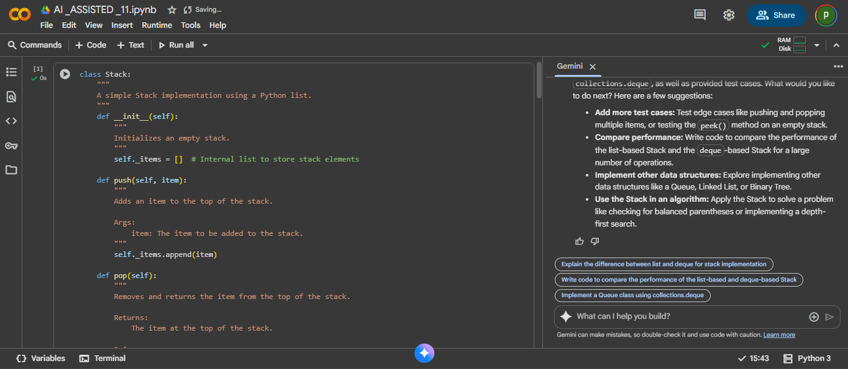
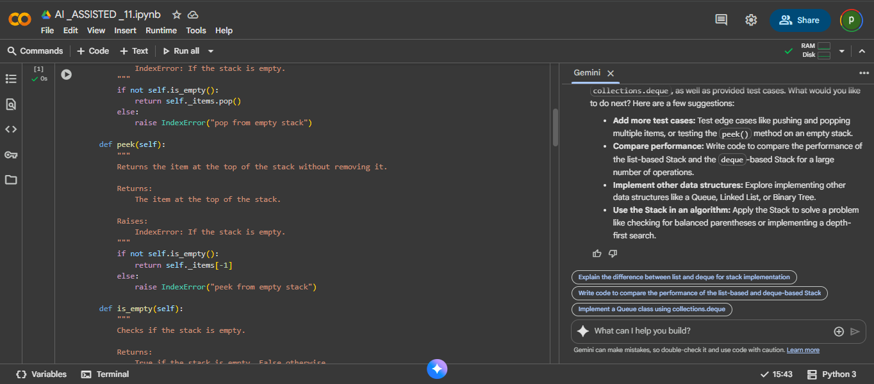
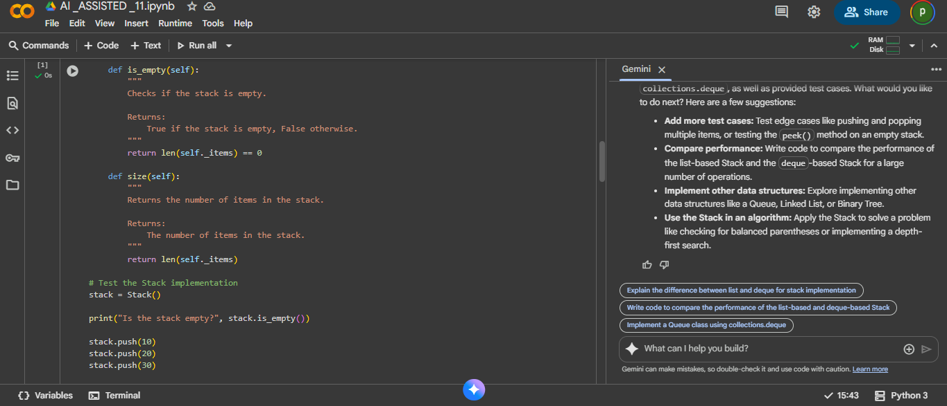
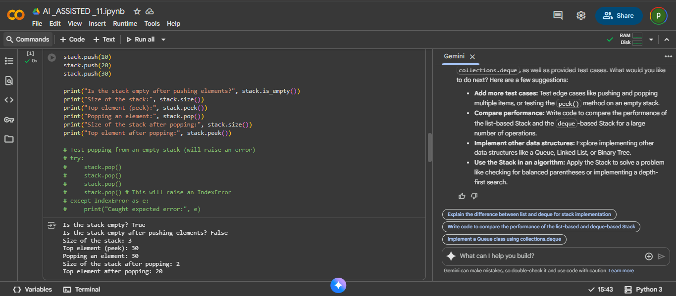
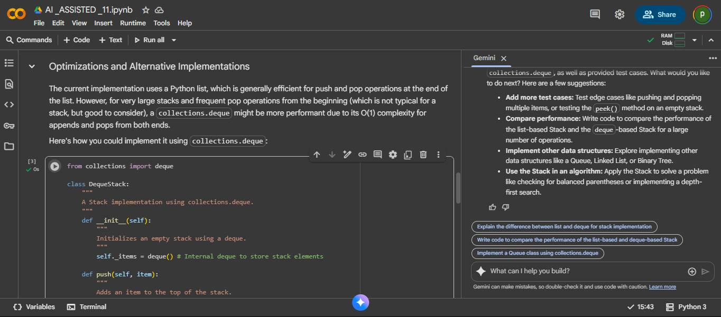
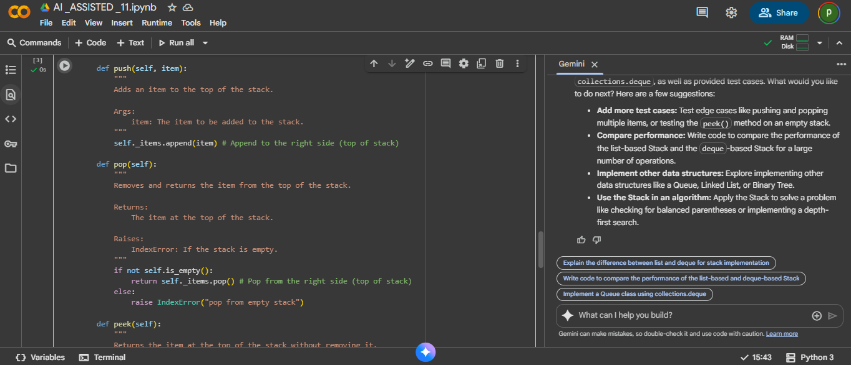
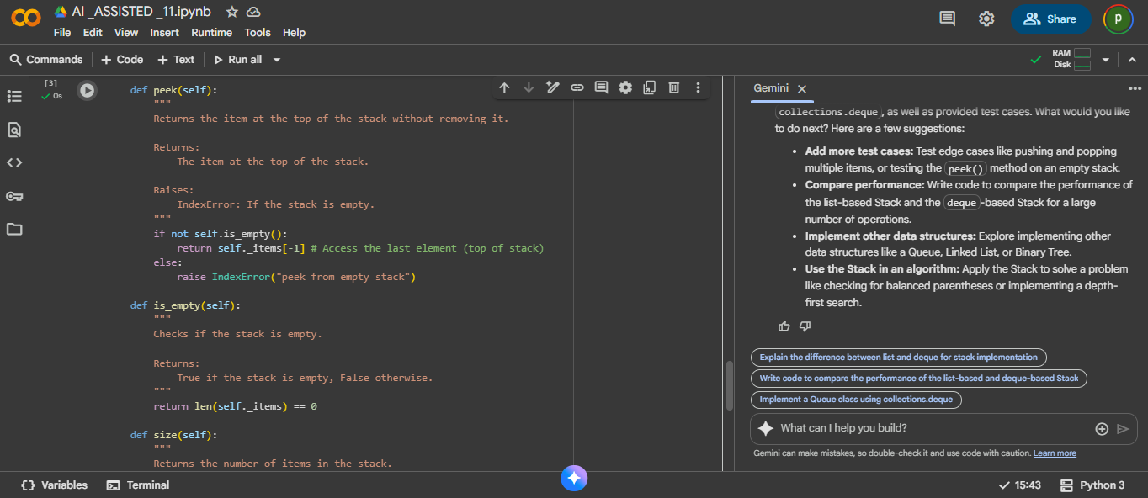
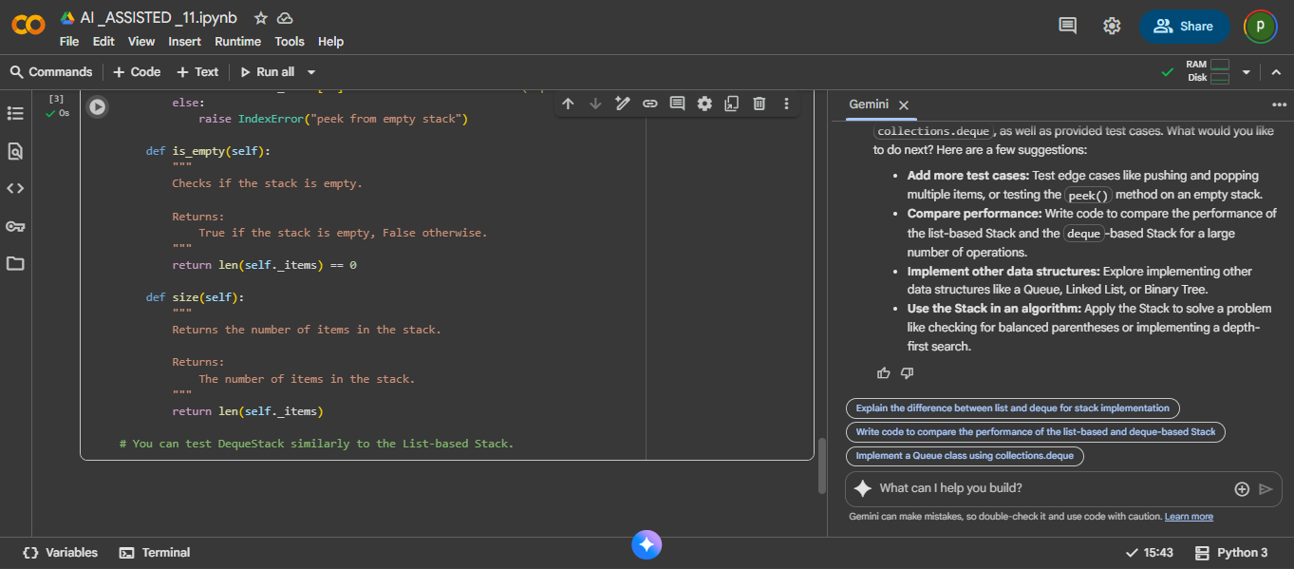

EXPLANATION:
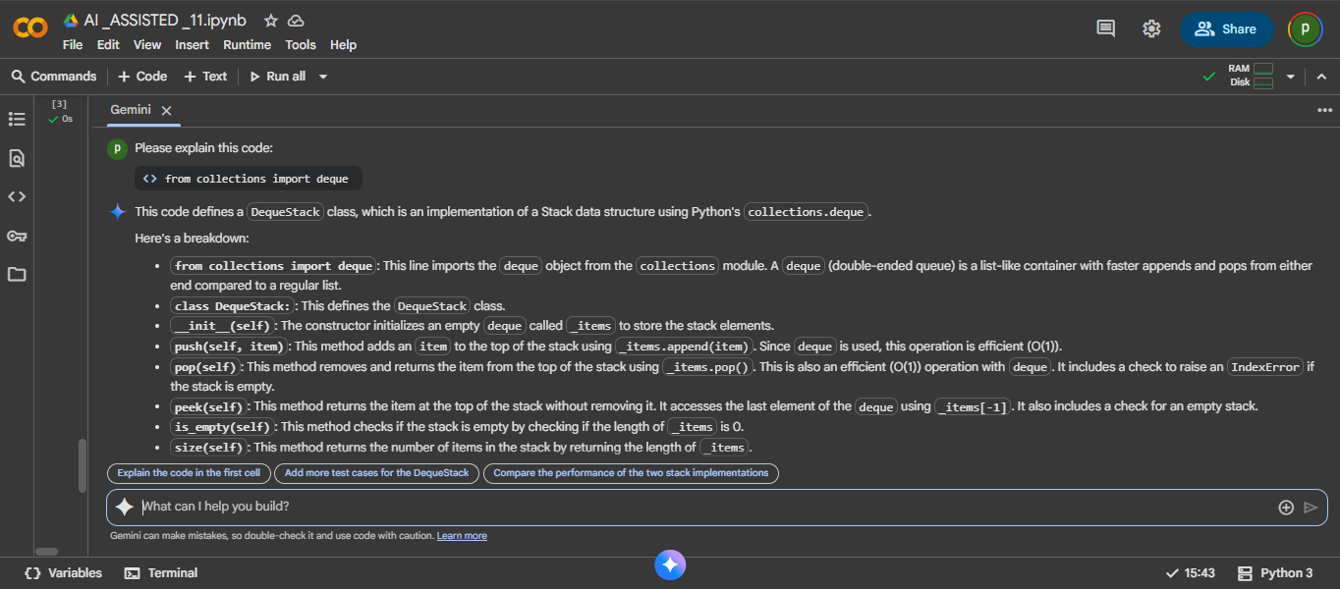
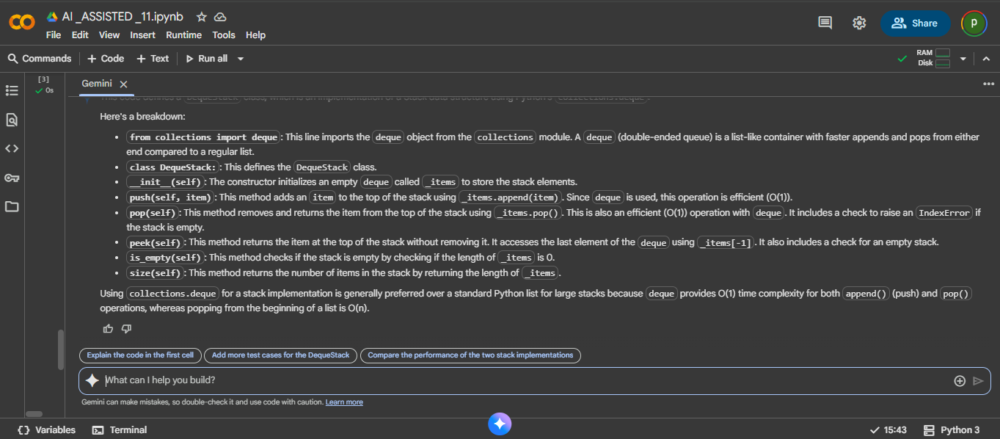

Task 2: Queue Implementation with Performance Review
- Task: Implement a Queue with enqueue(), dequeue(), and is_empty() methods.

